Mini Project # 5

Name of group members: VEDANT KUMAR, JUBEYER RAHMAN

ID: vxk180003, 2021453087 (jxr180022)

Contribution of each group member: Vedant (Q1) Jubeyer (Q2)



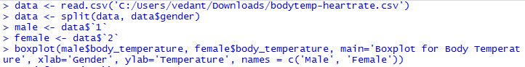

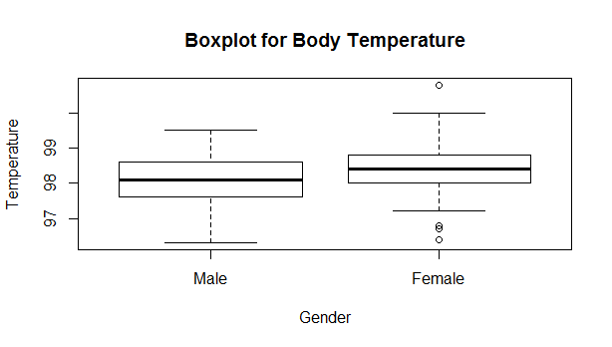

From the above boxplot, it can be deduced that

* Male
  + Min Value: 96.2
  + Max Value: 99.5
  + Median: 98.05
  + Quantiles: 25th -> 97.6, 75th -> 98.5
  + Range: 96.1 to 99.5
  + Outliers: No
* Female
  + Min Value: 96.3
  + Max Value: 100.9
  + Median: 98.25
  + Quantiles: 25th -> 98.05, 75th -> 98.75
  + Range: 96.3 to 100.9
  + Outliers: Yes, 96.3, 96.8, 96.9, 100.9

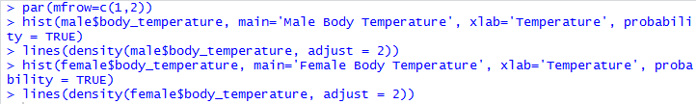

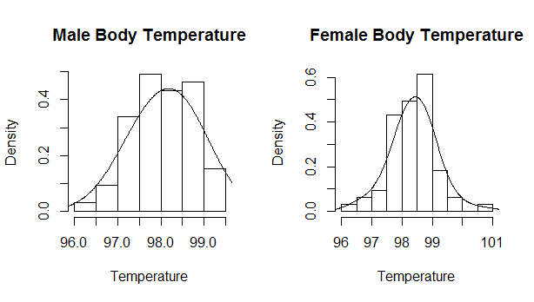

From the above density histogram curve it can be deduced that:

* Male
  + Mean: 98.1
  + Mode: 97.5 – 98
* Female
  + Mean: 98.4
  + Mode: 98.5 – 99

It can be said from the above results that the mean of Male Body Temperature is less than mean of Female Body Temperature.

The results from graph can be matched mathematically

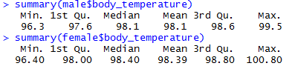



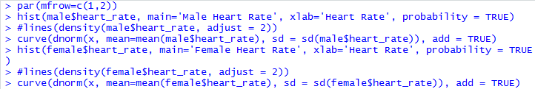

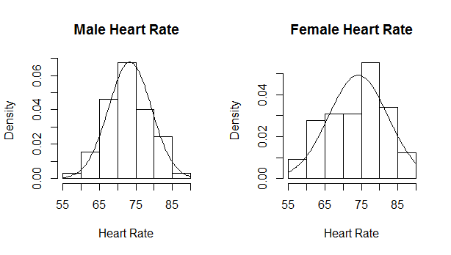

From the graph, the heart rate of Male and Female are both close to 74.

Mathematically, the mean of Male and Female is

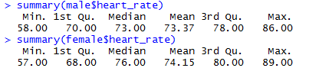





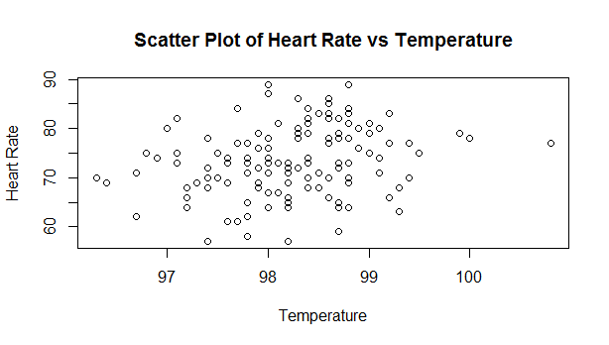

The Heart Rate and Temperature doesn’t follow a linear relationship. Mathematically, it can be checked



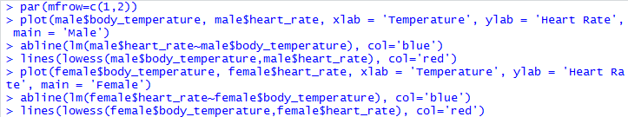

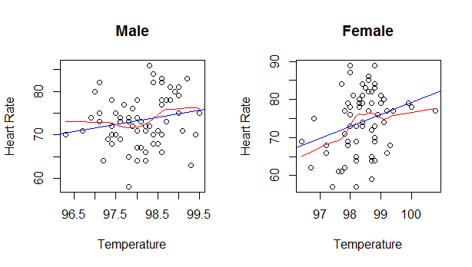

For each of the gender, no linear relationship can be found between heart rate and temperature. Fitting the data into linear model doesn’t give satisfactory results. The blue line above shows regression line and red line shows non-parametric line. Since, most of the points are out of the line it can be well established that there seems to be no linear relationship among the data. Mathematically it can be checked by

